Sayem Chowdhury

CSE:2110 (Computer Science I)

Homework Assihnment #1

Professor: Salaymeh

**Chapter (8)**

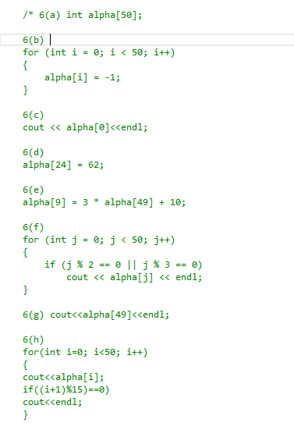

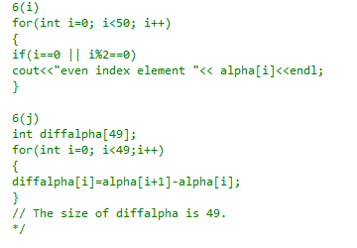

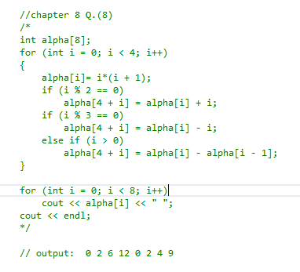

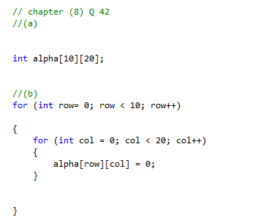

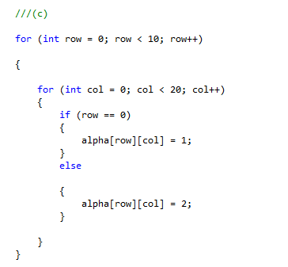

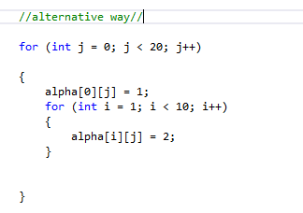

//d

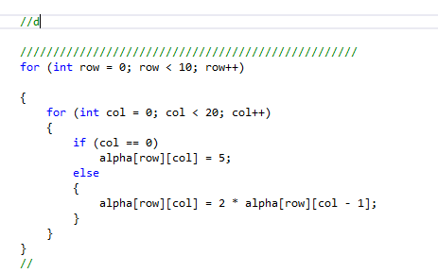

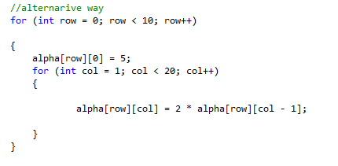

//(e)

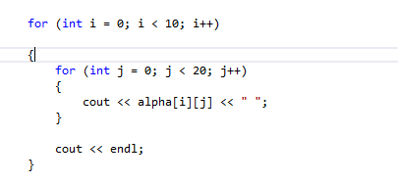

//(f)

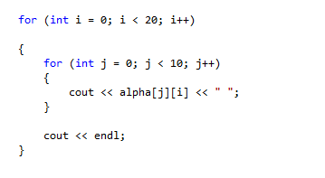

//Chapter 10

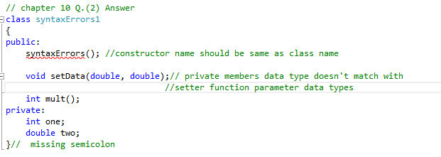

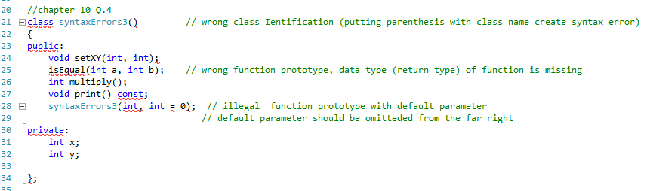

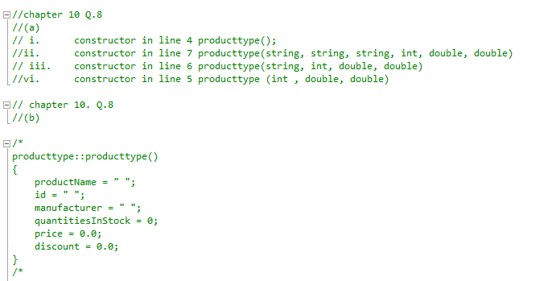

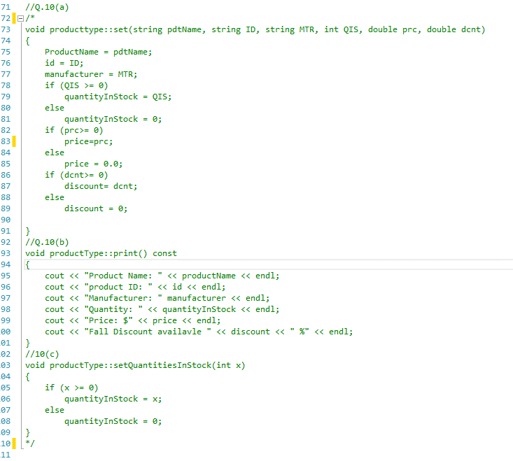

//Q.17

// Two built in operators are valid for class objects member access operator (.) and assignment operator (=).

//Q18

// The only difference between a struct and a class is that by default all the members of a struct are public but by default the members of a class are private.

// Q.23

/*

A class constructor is a special member function of a class that is executed whenever we create new objects of that class. Constructor will have exact same name as the class and it does not have any return type at all, not even void.

A constructor can have any number of parameters and a class may have any number of overloaded constructors

We include constructor to guarantee that member variables of a class are initialized.

*/